* - [Instructor] Properties are literally the properties of the object .
* *They describe different aspects of the object .*
* ***Object properties are defined using a colon separated name value pair, where the name can be any string and is placed on the left .***

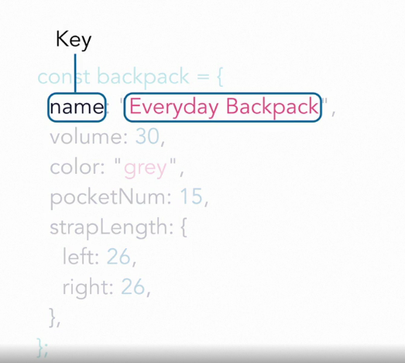

* And the value can be any

1. string inside quotation marks or b) an integer or a c) floating point number or d) a Boolean value as a true or false or an array, or e) even another object, placed on the right .

* You control the property names .
* And in JS the standard states, a property name can only contain **letters, digits, dollar signs, and underscores .**
* If you add quotation marks or hyphens or other symbols the object will not function properly and JavaScript will crash because there'll be incorrect code inside the object definition .

* The rule of thumb here to make sure everything works properly is to simply use camel case for property names .